Experiment- 6
Branch: MCA (AI&ML) | Semester: 2
Student Name: Ajay Rakwal | UID: 25MCI10329
Subject Name: Technical Training | Subject Code: 25CAP-652
Section/Group: MAM-1(A) | Date of Performance: 24-02-2026

Aim of the program:
Learn how to create, query, and manage views in SQL to simplify database queries and provide a layer of abstraction for end-users.

Software Requirements
- Operating System: Windows / Linux
- Database Management System: MySQL / Oracle / PostgreSQL
- SQL Interface: MySQL Workbench /Web Based / pgAdmin

Objective
- Data Abstraction: To understand how to hide complex table joins and calculations behind a simple virtual table interface.
- Enhanced Security: To learn how to restrict user access to sensitive columns by providing views instead of direct table access.
- Query Simplification: To master the creation of views that pre-join multiple tables, making reporting easier for non-technical users.
- View Management: To understand the syntax for creating, altering, and dropping views, as well as the naming conventions required for efficient data access.
Procedure of the Practical
- Open the database environment (Oracle / MS SQL Server / PostgreSQL) and connect to the required database.
- Create base tables such as Employees and Departments, and insert sample records for testing.
- Create a Simple View to filter specific records (e.g., active employees) without exposing the full table structure.
- Execute SELECT queries on the simple view to verify that it retrieves filtered data correctly.
- Create a Join View by combining multiple tables (e.g., Employees and Departments) to simplify complex queries.
- Query the join view to confirm that data from multiple tables is displayed in a consolidated format.
- Create an Advanced View using aggregate functions (e.g., COUNT, AVG, SUM) and GROUP BY to generate department-level statistics.
- Test the summarization view to validate calculated outputs.
- Demonstrate view management operations such as ALTER VIEW and DROP VIEW.
- Verify access control by granting permissions on views instead of base tables (if applicable).

Practical / Experiment Steps
-- TABLE CREATION
CREATE TABLE departments (
department_id INT PRIMARY KEY,
department_name VARCHAR(100)
);
CREATE TABLE employees (
id INT PRIMARY KEY,
name VARCHAR(100),
salary NUMERIC(10,2),
status VARCHAR(20),
department_id INT,
FOREIGN KEY (department_id)
REFERENCES departments(department_id)
);
-- INSERT SAMPLE DATA
INSERT INTO departments VALUES
(1, 'HR'),
(2, 'IT'),
(3, 'Finance');
INSERT INTO employees VALUES
(101, 'Ajay', 50000, 'Active', 2),
(102, 'Jatin', 45000, 'Inactive', 1),
(103, 'Nidhi', 60000, 'Active', 2),
(104, 'Anay', 40000, 'Active', 3);
-- Simple View
CREATE VIEW active_employees AS
SELECT id, name, department_id
FROM employees
WHERE status = 'Active';
-- Join View
CREATE VIEW employee_department_view AS
SELECT e.id, e.name, d.department_name
FROM employees e
JOIN departments d
ON e.department_id = d.department_id;
-- Summary View
CREATE VIEW department_summary AS
SELECT department_id,
COUNT(*) AS total_employees,
AVG(salary) AS average_salary
FROM employees
GROUP BY department_id;
SELECT * FROM active_employees;
SELECT * FROM employee_department_view;
SELECT * FROM department_summary;

I/O Analysis (Input / Output)
Input
- Base table creation queries
- Sample data insertion commands
- CREATE VIEW statements (simple and complex views)
- SELECT queries on created views
- Aggregate function and JOIN queries
- ALTER VIEW and DROP VIEW commands

Output
- Base tables created successfully
- Simple view displaying filtered employee data
- Join view showing consolidated employee-department information
- Summarization view displaying department-level statistics
- Views modified and dropped successfully
- Simplified and secure data access achieved through views

OUTPUT:
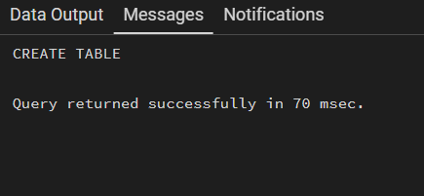
Table Created:

Insert sample records:
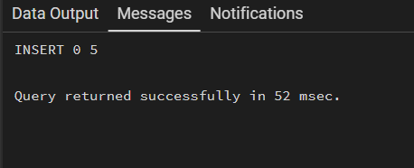

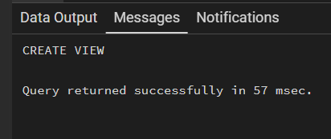
--Views creation

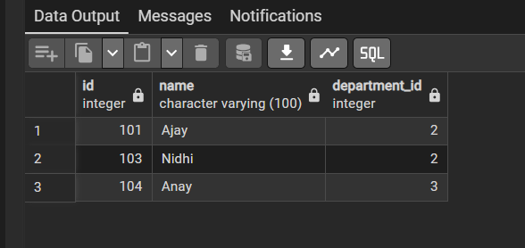
-- Simple View

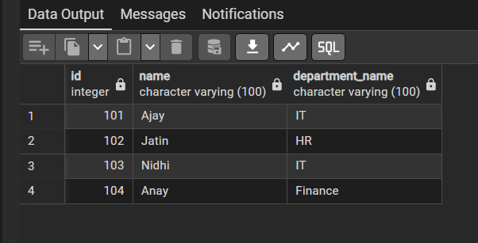
-- Join View

--Summary View
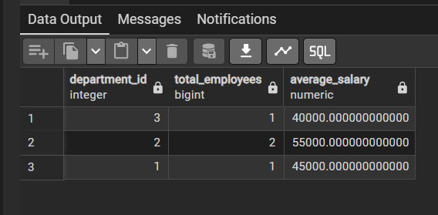

Learning Outcome:
- Understand the concept of views and their role in data abstraction.
- Learn how to create simple and complex views using SQL syntax.
- Gain practical experience in simplifying queries using join-based and aggregate views.
- Understand how views enhance database security by restricting access to sensitive columns.
- Develop the ability to design enterprise-level reporting views for real-world applications such as payroll and management systems.

